**9 Class Final Term Exam**

**Mathematics**

**Maximum Marks = 80**

**Total Time = 3H**

**General Instructions:**

1. **This Question Paper has 5 Sections A-E.**
2. **Section A has 20 MCQs carrying 1 mark each.**
3. **Section B has 5 questions carrying 02 marks each.**
4. **Section C has 6 questions carrying 03 marks each.**
5. **Section D has 4 questions carrying 05 marks each.**
6. **Section E has 3 case based integrated units of assessment (04 marks each) with subparts of the values of 1, 1 and 2 marks each respectively.**
7. **All Questions are compulsory. However, an internal choice in 2 Qs of 5 marks, 2 Qs of 3 marks and 2 Questions of 2 marks has been provided. An internal choice has been provided in the 2marks questions of Section E.**
8. **Draw neat figures wherever required. Take π =22/7 wherever required if not stated.**

**Section-A**

1. **The abscissa of a point is the distance of the point from**

**a) None of these**

**b) origin**

**c) x-axis**

**d) y-axis**

1. **The measure of each side of an equilateral triangle whose area is 3–√3 cm2 is**

**a) 8 cm**

**b) 4 cm**

**c) 2 cm**

**d) 16 cm**

1. **If a chord of a circle is equal to its radius, then the angle subtended by this chord in major segment is**

**a) 30o**

**b) 90o**

**c) 45o**

**d) 60o**

1. **The graph given below shows the frequency distribution of the age of 22 teachers in a school. The number of teachers whose age is less than 40 years is  
   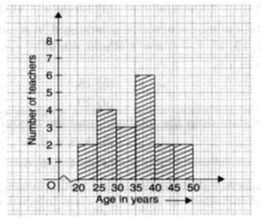**

**a) 17**

**b) 16**

**c) 15**

**d) 14**

1. **After rationalising the denominator of 7/3√3-2√2, we get the denominator as**

**a) 5**

**b) 35**

**c) 19**

**d) 13**

1. **If two acute angles of a right triangle are equal, then each acute is equal to**

**a) 45°**

**b) 60°**

**c) 30°**

**d) 90°**

1. **Any solution of the linear equation 2x + 0y + 9 = 0 in two variables is of the form**

**a) (−9/2,m)**

**b) (-9 , 0)**

**c) (0,−9/2)**

**d) (n,−9/2)**

1. **If x−1/x=15/4, then x+1/x =**

**a) 4**

**b) 1414**

**c) 174174**

**d) 134134**

1. **The value of (256x^16/81y^4)−1/4 is**

**a) 4y/5x^4**

**b) 3y/4x^4**

**c) 4x^4/3y**

**d) 3y/8x^4**

1. **The opposite sides of a quadrilateral have**

**a) two common points**

**b) no common point**

**c) one common point**

**d) infinitely many common points**

1. **If √13-a√10=√8+√5, then a =**

**a) -5**

**b) -2**

**c) -4**

**d) -6**

1. **Express y in terms of x in the equation 5y – 3x – 10 = 0.**

**a) y=3–10x/5**

**b) y=3+10x/5**

**c) y=3x–10/5**

**d) y=3x+10/5**

1. **Two angles measure (70 + 2x)o and (3x – 15)o. If each angle is the supplement of the other, then the value of x is :**

**a) 30**

**b) 20**

**c) 25000**

**d) 25**

1. **(125/216)^-1/3 =**

**a) 6/5**

**b) 125**

**c) 5/6**

**d) 216**

1. **In the given figure ABCD and ABEF are cyclic quadrilaterals. If ∠∠BCD = 110o then ∠∠BEF = ?  
   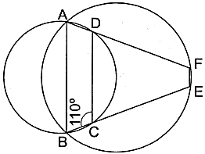**

**a) 90o**

**b) 70o**

**c) 55o**

**d) 110o**

1. **Point (- 10,0) lies**

**a) on the negative direction of the y-axis**

**b) on the negative direction of the X-axis**

**c) in the third quadrant**

**d) in the fourth quadrant**

1. **Every linear equation in two variables has**

**a) two solutions**

**b) no solution**

**c) an infinite number of solutions**

**d) one solution**

1. **(x + 1) is a factor of the polynomial**

**a) x3 + x2 – x + 1**

**b) x3 + x2 + x + 1**

**c) x4 + 3x3 + 3x2 + x + 1**

**d) x4 + x3 + x2 + 1**

1. **Assertion (A): If the diagonals of a parallelogram ABCD are equal, then ∠∠ABC = 90o  
   Reason (R): If the diagonals of a parallelogram are equal, it becomes a rectangle.**

**a) Both A and R are true and R is the correct explanation of A.**

**b) Both A and R are true but R is not the correct explanation of A.**

**c) A is true but R is false.**

**d) A is false but R is true.**

1. **Assertion (A): The rationalised form of 1/√7−2 is √7 + 2.  
   Reason (R): The conjugate of √7 – 2 is √7 + 2.**

**a) Both A and R are true and R is the correct explanation of A.**

**b) Both A and R are true but R is not the correct explanation of A.**

**c) A is true but R is false.**

**d) A is false but R is true.**

**Section-B**

1. **Solve the equation a – 15 = 25 and state which axiom do you use here.**
2. **It is known that x + y = 10 and that x = z. Show that z + y = 10?**
3. **Write the co-ordinates of each of the following points marked in the graph paper.  
   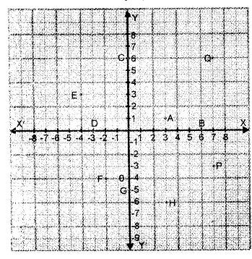**
4. **Simplify : 22/ 3. 21/5**

**OR**

**If a=3+√5/2, then find the value of a^2+1/a^2.**

1. **Harish was a student of 9th class. Once his birthday party was arranged in a restaurant. He got a playing top (lattu) as his birthday present, which surprisingly had no color on  
   it. He wanted to color it with his crayons. The top is shaped like a cone surmounted by a hemisphere as shown in the figure. The entire top of each lattu is 5 cm in height and the diameter of the top is 3.5 cm. Rashid wants to color the hemispherical part by red color and the conical part by green color.  
   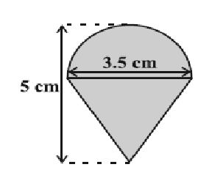  
   Answer the following questions:**
   1. **What is the area to be colored by red color?**
   2. **Also, find the area to be colored by green color.**

**OR**

**Find the ratio of the curved surface areas of two cones if their diameters of the bases are equal and slant heights are in the ratio 4 : 3.**

**Section-C**

1. **If a = xyp-1, b = xyq-1 and c = xyr-1, prove that aq-r br-p cp-q = 1**
2. **Construct a histogram for the following data:**

|  |  |  |  |  |  |  |  |
| --- | --- | --- | --- | --- | --- | --- | --- |
| **Monthly School fee (in ₹):** | **30-60** | **60-90** | **90-120** | **120-150** | **150-180** | **180-210** | **210-240** |
| **No of Schools** | **5** | **12** | **14** | **18** | **10** | **9** | **4** |

1. **In Figure  AD and BE are medians of  ΔΔABC and BE || DF. Prove that CF = 1414 AC.  
   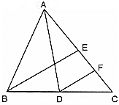**
2. **Find at least 3 solutions for the following linear equation in two variables:  
   2x + 5y = 13**
3. **Draw a histogram of the following distribution:**

|  |  |
| --- | --- |
| **Height (in cm)** | **Number of students** |
| **150 – 153** | **7** |
| **153 – 156** | **8** |
| **156 – 159** | **14** |
| **159 – 162** | **10** |
| **162 – 165** | **6** |
| **165 – 168** | **5** |

1. **OR**
2. **The production of oil (in lakh tonnes) in some of the refineries in India during 1982 was given below:**

|  |  |  |  |  |  |
| --- | --- | --- | --- | --- | --- |
| **Refinery:** | **Barauni** | **Koyali** | **Mathura** | **Mumbai** | **Florida** |
| **Production of oil (in lakh tonnes)** | **30** | **70** | **40** | **45** | **25** |

1. **Construct a bar graph to represent the above data so that the bars are drawn horizontally.**
2. **Factorize: 2√2 x^3+3√3 y^3+√5(5−3√6 xy)**

**Section-D**

1. **In the given figure, AB ∥∥ CD. Find the value of x∘.  
   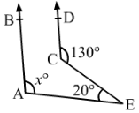**

**OR**

**In the given figure, l || m and a transversal t cuts them. If ∠1:∠2=2:3∠1:∠2=2:3, find the measure of each of the marked angles.  
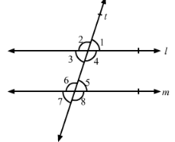**

1. **A right angled triangle with sides 3 cm and 4 cm is revolved around its hypotenuse. Find the volume of the double cone thus generated.**
2. **Find the area of the triangle whose sides are 42 cm, 34 cm and 20 cm in length. Hence, find the height corresponding to the longest side.**

**OR**

**The perimeter of a triangle is 50 cm. One side of a triangle is 4 cm longer than the smaller side and the third side is 6 cm less than twice the smaller side. Find the area of the triangle.**

1. **Let R1 and R2 are the remainders when the polynomials x3 + 2x2– 5ax – 7 and x3+ ax2– 12x + 6 are divided by x + 1 and x – 2 respectively. If 2R1+ R2 = 6 , find the value of a.**

**Section-E**

1. **Read the text carefully and answer the questions:  
   Peter, Kevin James, Reeta and Veena were students of Class 9th B at Govt Sr Sec School, Sector 5, Gurgaon.  
   Once the teacher told Peter to think a number x and to Kevin to think another number y so that the difference of the numbers is 10 (x > y).  
   Now the teacher asked James to add double of Peter’s number and that three times of Kevin’s number, the total was found 120.  
   Reeta just entered in the class, she did not know any number.  
   The teacher said Reeta to form the 1st equation with two variables x and y.  
   Now Veena just entered the class so the teacher told her to form 2nd equation with two variables x and y.  
   Now teacher Told Reeta to find the values of x and y. Peter and kelvin were told to verify the numbers x and y.  
   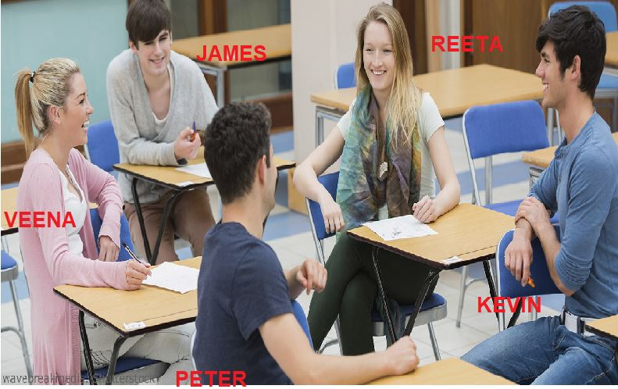**
   1. **What are the equation formed by Reeta and Veena?**
   2. **What was the equation formed by Veena?**
   3. **Which number did Peter think?**
   4. **OR**

**Which number did Kelvin think?**

1. **To practice more questions & prepare well for exams, download myCBSEguide App. It provides complete study material for CBSE, NCERT, JEE (main), NEET-UG and NDA exams. Teachers can use Examin8 App to create similar papers with their own name and logo.**
2. **Read the text carefully and answer the questions:  
   In the middle of the city, there was a park ABCD  in the form of a parallelogram form so that  AB = CD, AB||CD and AD = BC, AD || BC.  
   Municipality converted this park into a rectangular form by adding land in the form of ΔΔAPD and ΔΔ BCQ. Both the triangular shape of land were covered by planting flower plants.  
   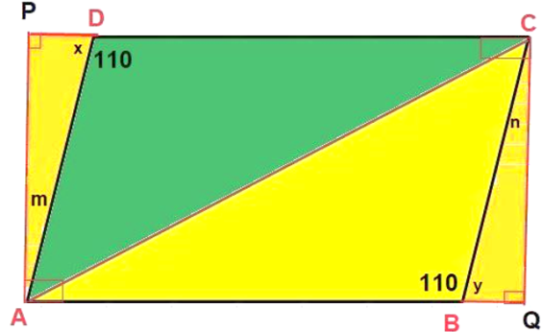**
   1. **Show that ΔΔAPD and ΔΔBQC are congruent.**
   2. **PD is equal to which side?**

**OR**

**What is the value of ∠m?**

* 1. **Show that ΔΔABC and ΔΔCDA are congruent.**

1. **Read the text carefully and answer the questions:  
   Mr. Vivekananda purchased a plot QRUT to build his house. He leaves space of two congruent semicircles for gardening and a rectangular area of breadth 3 cm for car parking.  
   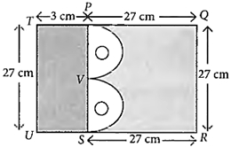**
   1. **Find the total area of Garden.**
   2. **Find the area of rectangle left for car parking.**
   3. **OR**

**Find the area of a semi-circle.**

* 1. **Find the radius of semi-circle.**